Project Design Phase-II
Technology Stack (Architecture & Stack)

Date | 28 September 2026
Team ID | SWTID-2026-5152
Project Name | AI FitWell – AI Personalized Fitness, Wellness and Meals Planner
Maximum Marks | 4 Marks

Technical Architecture:
The Deliverable shall include the architectural diagram as below and the information as per the table1 & table 2
Project: AI FitWell – Fitness & Wellness Assistant
Architecture derived from the supplied AI FitWell source ZIP and technology-stack template.

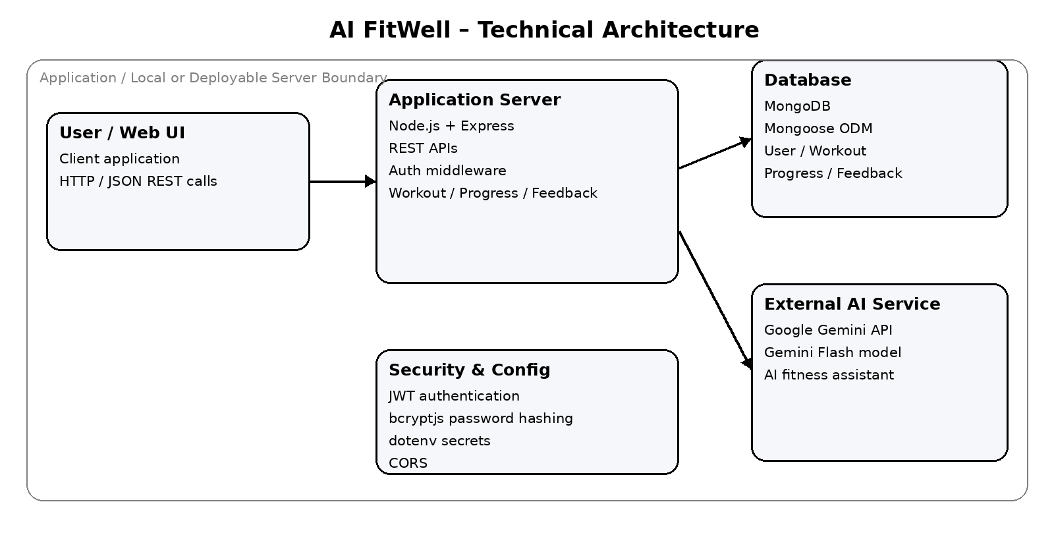

Table-1 : Components & Technologies:
S.No | Component | Description | Technology
1 | User Interface | Web client is referenced by the Express server through ../client/index.html. The supplied ZIP does not contain the client source files, so the exact frontend framework cannot be verified. | Web UI; client technology not verifiable from supplied ZIP
2 | Application Logic-1 | User registration, login, profile retrieval/update and JWT-based authentication are implemented as REST endpoints. | Node.js; Express.js 5.2.1; jsonwebtoken 9.0.3; bcryptjs 3.0.3
3 | Application Logic-2 | Workout, progress and feedback creation/retrieval are implemented through protected REST API routes. | Express.js; JavaScript/CommonJS; Mongoose 9.10.2
4 | Application Logic-3 | AI chat endpoint accepts a user message and generates a fitness/wellness response using Gemini with a fallback model on HTTP 503. | Google GenAI SDK (@google/genai 2.24.0); Gemini Flash models
5 | Database | Document-oriented persistence for User, Workout, Progress and Feedback collections/models. | MongoDB with Mongoose ODM 9.10.2
6 | Cloud Database | No separate cloud database service is explicitly implemented. The application reads MongoDB connection details from MONGODB_URI. | MongoDB URI via environment configuration; cloud provider not specified
7 | File Storage | No dedicated file-storage service or upload workflow is present in the supplied backend. | None identified; local filesystem is only used to serve the referenced client directory
8 | External API-1 | Generates AI fitness and wellness assistant responses. | Google Gemini API via @google/genai
9 | External API-2 | No second external API is implemented in the supplied source. | None identified
10 | Machine Learning Model | Generative AI model used for fitness/wellness chat. The code tries Gemini 3.8 Flash first and Gemini 3.7 Flash when the first model returns HTTP 503. | Google Gemini 3.8 Flash; fallback Gemini 3.7 Flash
11 | Infrastructure (Server / Cloud) | Express application runs on Node.js and listens on port 5000 after MongoDB connection. No cloud deployment, container, Kubernetes or load-balancer configuration is included in the supplied ZIP. | Node.js + Express; local/default endpoint http://localhost:5000; deployment target not specified

Table-2: Application Characteristics:
S.No | Characteristics | Description | Technology
1 | Open-Source Frameworks | Backend uses Express.js and Mongoose; supporting packages include CORS, dotenv and Nodemon for development. | Node.js; Express.js 5.2.1; Mongoose 9.10.2; cors 2.8.6; dotenv 18.0.3; nodemon 3.1.14
2 | Security Implementations | Passwords are hashed with bcryptjs. Protected routes verify JWTs using JWT_SECRET. Secrets are loaded through dotenv. CORS middleware is enabled. | bcryptjs 3.0.3; jsonwebtoken 9.0.3; dotenv 18.0.3; CORS
3 | Scalable Architecture | The backend is organized into routes, models, middleware and services, providing modular separation of concerns. The supplied source shows a single Express application rather than microservices. | Express.js REST API; modular route/model/service structure
4 | Availability | The AI service includes a fallback from Gemini 3.8 Flash to Gemini 3.7 Flash when a 503 response occurs. No load balancer, replica set, distributed server or failover infrastructure is specified. | Gemini model fallback; no explicit HA infrastructure in supplied ZIP
5 | Performance | Uses asynchronous Express handlers and Mongoose operations. Database queries sort recent records by date. No caching, CDN, rate-limit or requests-per-second target is specified in the supplied source. | Async/await; Mongoose queries; no explicit cache/CDN configuration

References:
https://expressjs.com/
https://www.mongodb.com/docs/
https://mongoosejs.com/docs/
https://ai.google.dev/gemini-api/docs
https://www.npmjs.com/package/jsonwebtoken

